Code:  
#include <stdio.h>

#include <string.h>

#include <ctype.h>

#include <stdbool.h>

bool isArithmeticOperator(char ch) {

    return (ch == '+' || ch == '-' || ch == '\*' || ch == '/' || ch == '%' ||

            ch == '=' || ch == '<' || ch == '>' || ch == '!' || ch == '&' ||

            ch == '|' || ch == '^' || ch == '~');

}

bool isMultiCharOperator(char \*str, int pos) {

    if (pos < strlen(str) - 1) {

        char current = str[pos];

        char next = str[pos + 1];

        if ((current == '+' && next == '+') ||

            (current == '-' && next == '-') ||

            (current == '=' && next == '=') ||

            (current == '!' && next == '=') ||

            (current == '<' && next == '=') ||

            (current == '>' && next == '=') ||

            (current == '&' && next == '&') ||

            (current == '|' && next == '|') ||

            (current == '<' && next == '<') ||

            (current == '>' && next == '>'))

            return true;

    }

    return false;

}

int countOperators(char \*input) {

    int count = 0;

    int len = strlen(input);

    printf("\n TASK 4\n");

    printf("Input string: %s\n", input);

    printf("Operators found: ");

    for (int i = 0; i < len; i++) {

        if (isMultiCharOperator(input, i)) {

            printf("%.2s ", &input[i]);

            count++;

            i++;

        }

        else if (isArithmeticOperator(input[i])) {

            printf("%c ", input[i]);

            count++;

        }

    }

    printf("\nTotal operators count: %d\n", count);

    return count;

}

bool validateInputString(char \*input) {

    int len = strlen(input);

    bool isValid = true;

    printf("\n TASK 5\n");

    printf("Input string: \"%s\"\n", input);

    printf("Checking each character:\n");

    for (int i = 0; i < len; i++) {

        char ch = input[i];

        if (isalnum(ch)) {

            printf("'%c' - Valid (alphanumeric)\n", ch);

        }

        else if (isspace(ch)) {

            if (ch == ' ') {

                printf("' ' - Valid (whitespace)\n");

            } else if (ch == '\t') {

                printf("'\\t' - Valid (tab)\n");

            } else if (ch == '\n') {

                printf("'\\n' - Valid (newline)\n");

            } else {

                printf("'%c' - Valid (whitespace)\n", ch);

            }

        }

        else if (isArithmeticOperator(ch)) {

            printf("'%c' - Valid (arithmetic operator)\n", ch);

        }

        else {

            printf("'%c' - INVALID (not alphanumeric, whitespace, or arithmetic operator)\n", ch);

            isValid = false;

        }

    }

    printf("\nValidation result: %s\n", isValid ? "VALID" : "INVALID");

    return isValid;

}

int main() {

    char codeSnippet[256];

    char validateStr[256];

    printf("Enter code snippet to count operators: ");

    fgets(codeSnippet, sizeof(codeSnippet), stdin);

    printf("Enter string to validate: ");

    fgets(validateStr, sizeof(validateStr), stdin);

    countOperators(codeSnippet);

    validateInputString(validateStr);

    return 0;

}

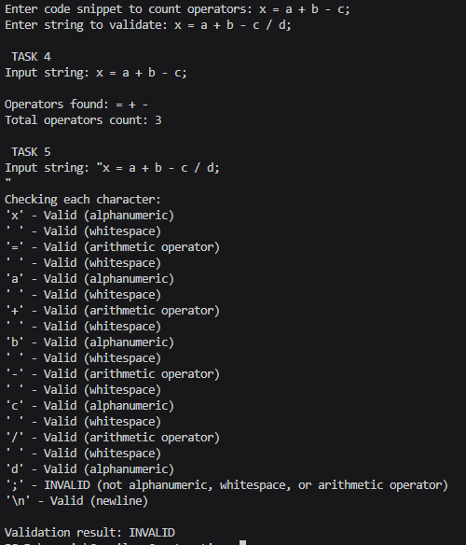Output: